**Excel Assignment - 6**

1. What are the various elements of the Excel interface? Describe how

they're used.

**Ans:** various elements of the Excel interface 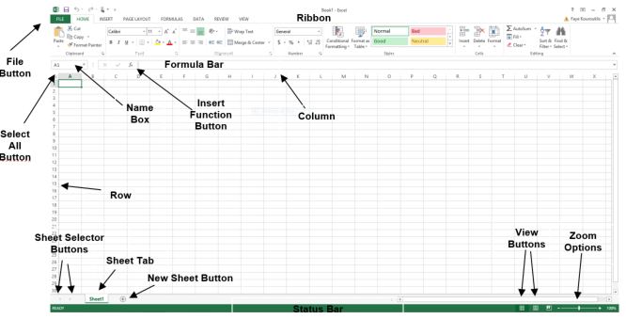

|  |  |
| --- | --- |
| Interface Element | Description |
| Ribbon Tabs | Ribbon Tab is a tab that organizes commands by topic |
| The Ribbon | Commands underneath the Tabs |
| Ribbon Groups | Grouping of related commands |
| Dialog Box Launcher | Opens a dialog box that includes additional commands |
| Quick Access Toolbar | One click access to any frequently used command |
| Name Box | Displays cell location and can be used to navigate to a cell location |
| Select All Button | Selects all the cells in a worksheet |
| Formula Bar | View, enter, or edit cell contents |
| Insert Function Button | Displays Insert Function dialog box |
| Scroll Bars | Used to navigate up, down, left & right |
| Zoom Slider | Zoom into an area of the worksheet |
| View Buttons | Switch between Normal, Page Layout and Page Break Preview views |
| Worksheet tabs | Tabs used to select individual worksheets |
| The Workspace | The area inside of the columns and rows used in Excel |
| Columns | Columns use letters |
| Rows | Rows use numbers |

 2. Write down the various applications of Excel in the industry.

**Ans:** various applications of Excel in the industry

* Data Entry and Storage
* Performing Calculations
* Data Analysis and Interpretation
* Reporting and Visualizations
* Accounting and Budgeting
* Collection and Verification of Business Data
* Calendars and Schedules
* Administrative and Managerial Duties
* Forecasting
* Automating Repetitive Tasks

3. On the ribbon, make a new tab. Add some different groups, insert

commands in the groups and name them according to their commands

added. Copy and paste the screenshot of the steps you followed.

**Ans:**

1. Open excel workbook. Go to File tab & then click Customise Ribbon tab

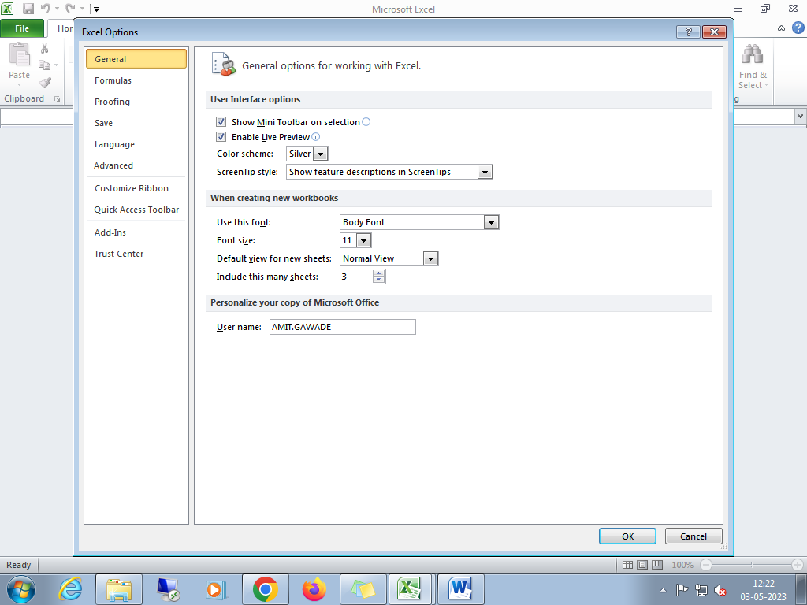

1. Add New group

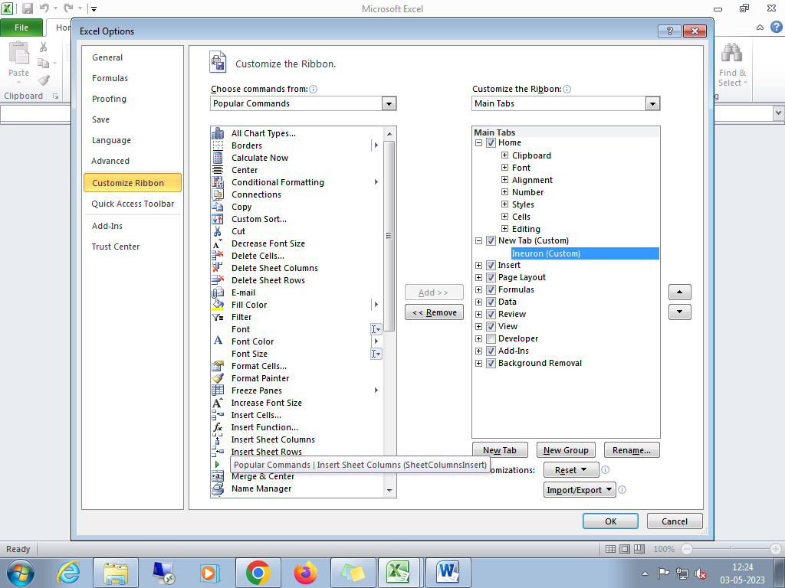

iii)Rename subgroup & add commands in that group.

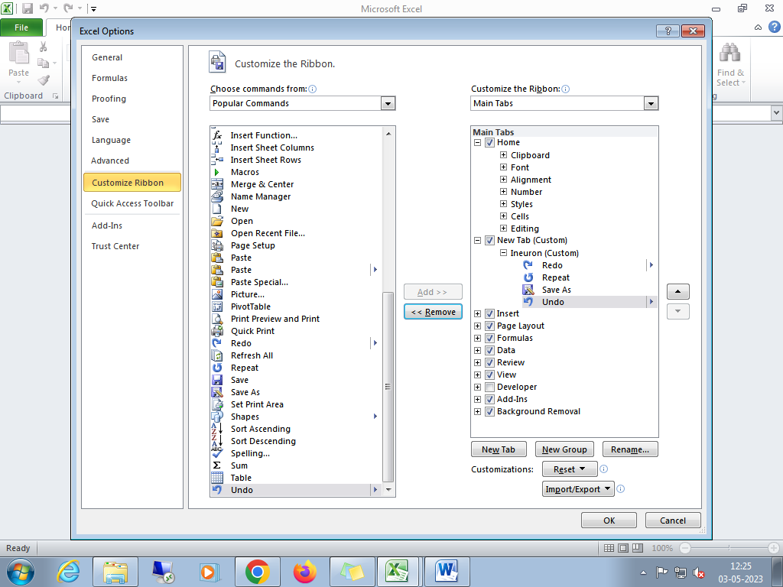

iv)Rename main group

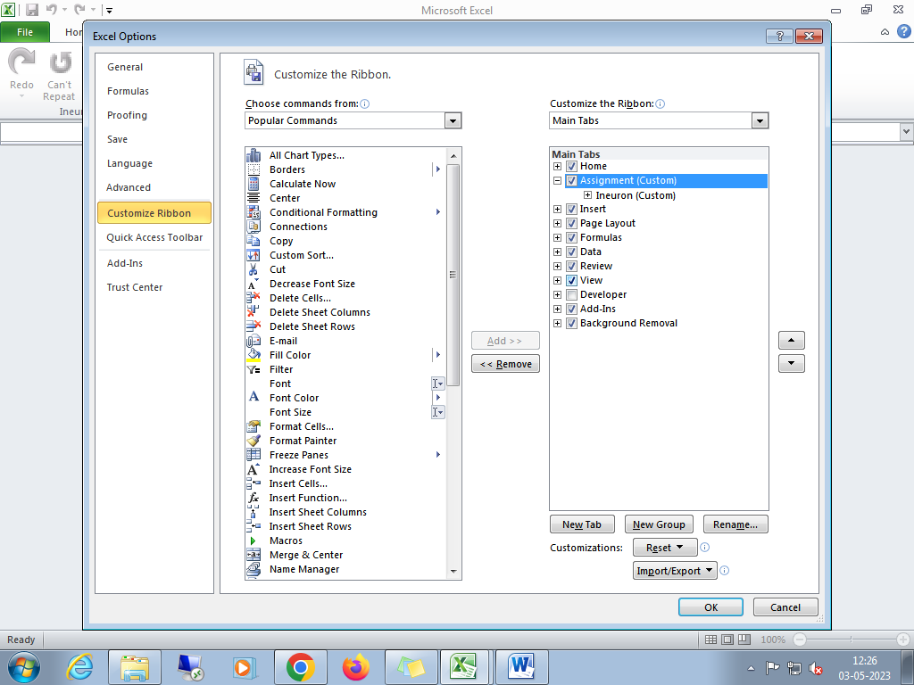

v) You can see the following commands in new group created.

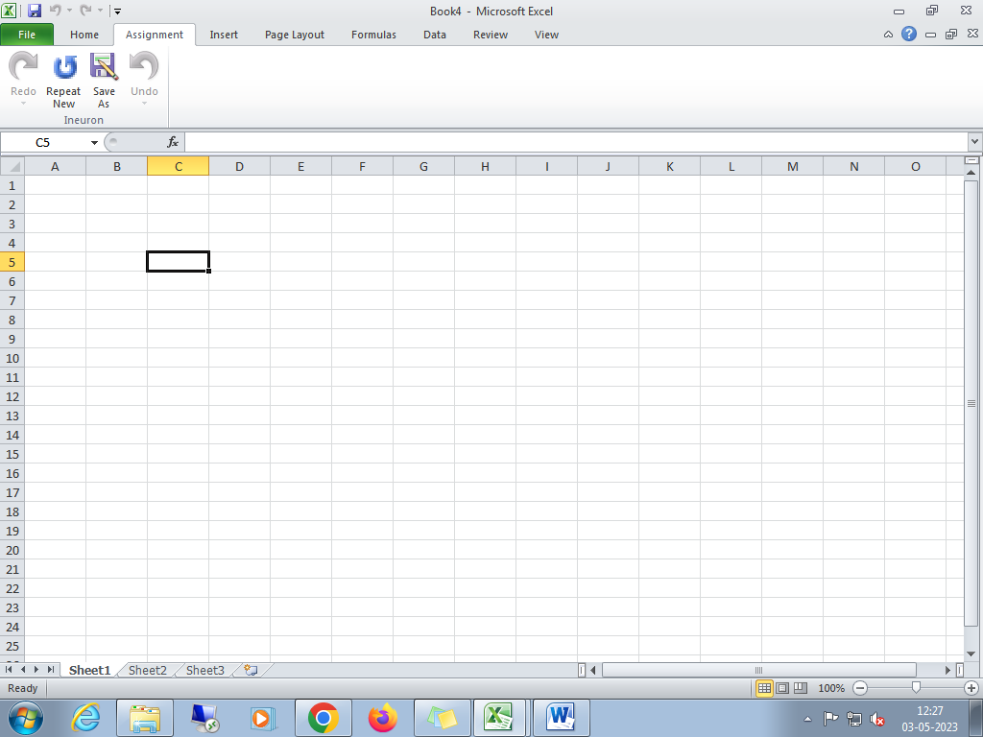

4. Make a list of different shortcut keys that are only connected to

formatting with their functions.

**Ans:** Keyboard shortcuts for formatting cells

| To do this | Press |
| --- | --- |
| Open the Format Cells dialog box. | Ctrl+1 |
| Format fonts in the Format Cells dialog box. | Ctrl+Shift+F or Ctrl+Shift+P |
| Edit the active cell and put the insertion point at the end of its contents. Or, if editing is turned off for the cell, move the insertion point into the formula bar. If editing a formula, toggle Point mode off or on so you can use the arrow keys to create a reference. | F2 |
| Insert a note.  Open and edit a cell note. | Shift+F2  Shift+F2 |
| Insert a threaded comment.  Open and reply to a threaded comment. | Ctrl+Shift+F2  Ctrl+Shift+F2 |
| Open the Insert dialog box to insert blank cells. | Ctrl+Shift+Plus sign (+) |
| Open the Delete dialog box to delete selected cells. | Ctrl+Minus sign (-) |
| Enter the current time. | Ctrl+Shift+Colon (:) |
| Enter the current date. | Ctrl+Semicolon (;) |
| Switch between displaying cell values or formulas in the worksheet. | Ctrl+Grave accent (`) |
| Copy a formula from the cell above the active cell into the cell or the formula bar. | Ctrl+Apostrophe (') |
| Move the selected cells. | Ctrl+X |
| Copy the selected cells. | Ctrl+C |
| Paste content at the insertion point, replacing any selection. | Ctrl+V |
| Open the Paste Special dialog box. | Ctrl+Alt+V |
| Italicize text or remove italic formatting. | Ctrl+I or Ctrl+3 |
| Bold text or remove bold formatting. | Ctrl+B or Ctrl+2 |
| Underline text or remove underline. | Ctrl+U or Ctrl+4 |
| Apply or remove strikethrough formatting. | Ctrl+5 |
| Switch between hiding objects, displaying objects, and displaying placeholders for objects. | Ctrl+6 |
| Apply an outline border to the selected cells. | Ctrl+Shift+Ampersand sign (&) |
| Remove the outline border from the selected cells. | Ctrl+Shift+Underscore (_) |
| Display or hide the outline symbols. | Ctrl+8 |
| Use the Fill Down command to copy the contents and format of the topmost cell of a selected range into the cells below. | Ctrl+D |
| Apply the General number format. | Ctrl+Shift+Tilde sign (~) |
| Apply the Currency format with two decimal places (negative numbers in parentheses). | Ctrl+Shift+Dollar sign ($) |
| Apply the Percentage format with no decimal places. | Ctrl+Shift+Percent sign (%) |
| Apply the Scientific number format with two decimal places. | Ctrl+Shift+Caret sign (^) |
| Apply the Date format with the day, month, and year. | Ctrl+Shift+Number sign (#) |
| Apply the Time format with the hour and minute, and AM or PM. | Ctrl+Shift+At sign (@) |
| Apply the Number format with two decimal places, thousands separator, and minus sign (-) for negative values. | Ctrl+Shift+Exclamation point (!) |
| Open the Insert hyperlink dialog box. | Ctrl+K |
| Check spelling in the active worksheet or selected range. | F7 |
| Display the Quick Analysis options for selected cells that contain data. | Ctrl+Q |
| Display the Create Table dialog box. | Ctrl+L or Ctrl+T |
| Open the Workbook Statistics dialog box. | Ctrl+Shift+G |

5. What distinguishes Excel from other analytical tools?

Ans: Microsoft Excel is one of the most popular applications for data analysis. Equipped with built-in pivot tables, they are without a doubt the most sought-after analytic tool available. It is an all-in-one data management software that allows you to easily import, explore, clean, analyze, and visualize your data

6. Create a table and add a custom header and footer to your table.

**Ans:** 